Step by Step install Helm chart

Install on AIE 1.6

Part 1: Deploy Vista model on MLIS

Go to MLIS

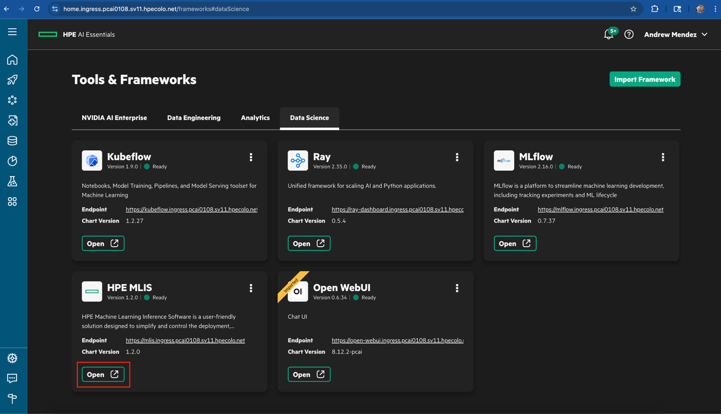

Next create registry select add new registry
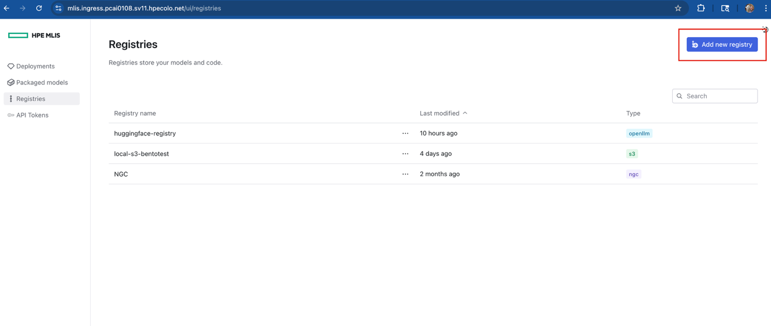
Fill in the information needed to create a registry, this will hold your nvidia enterprise API key
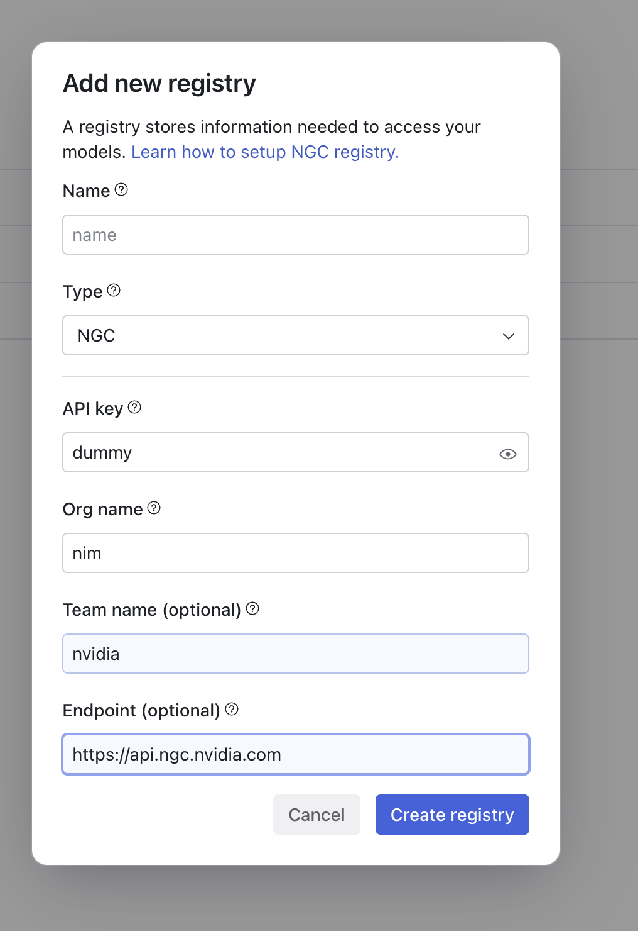

Next create a packaged model, name your model vista

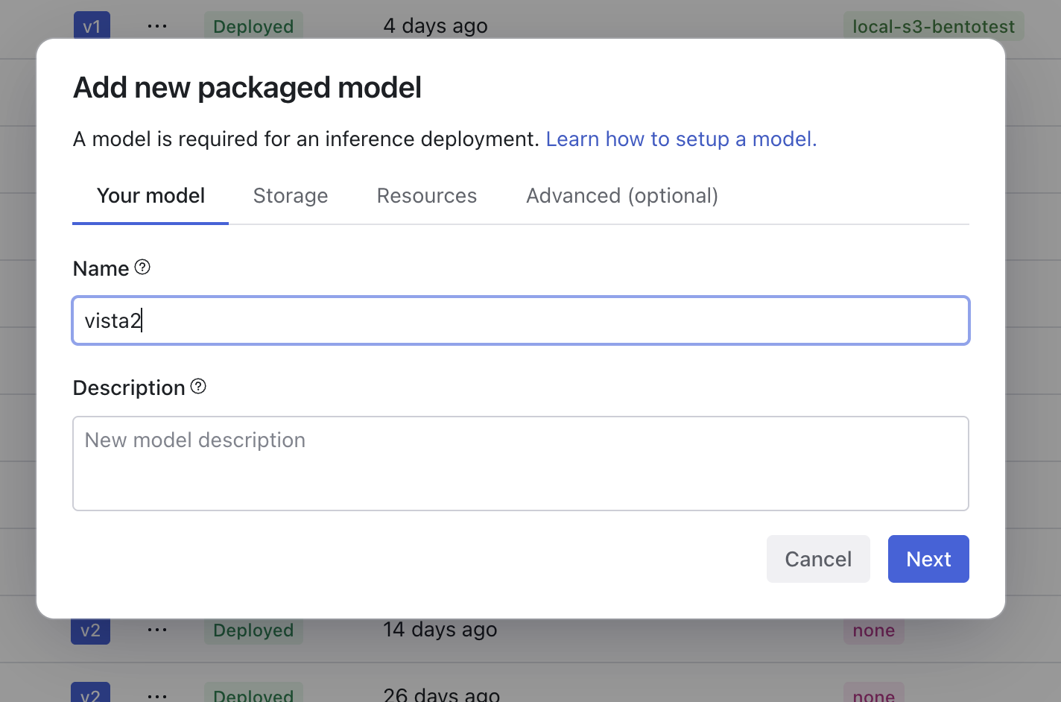
Select your registry and list of supported models will populate, select vista model docker image
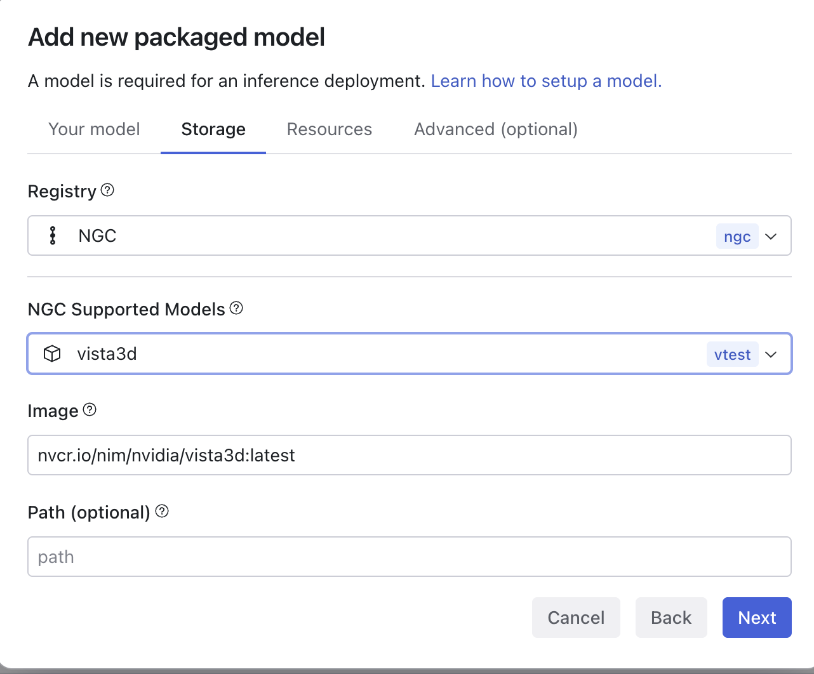

Next set resources to the following screenshot. Make sure to manually change gpu to 1 and 1, this model only needs 1 l40s GPU
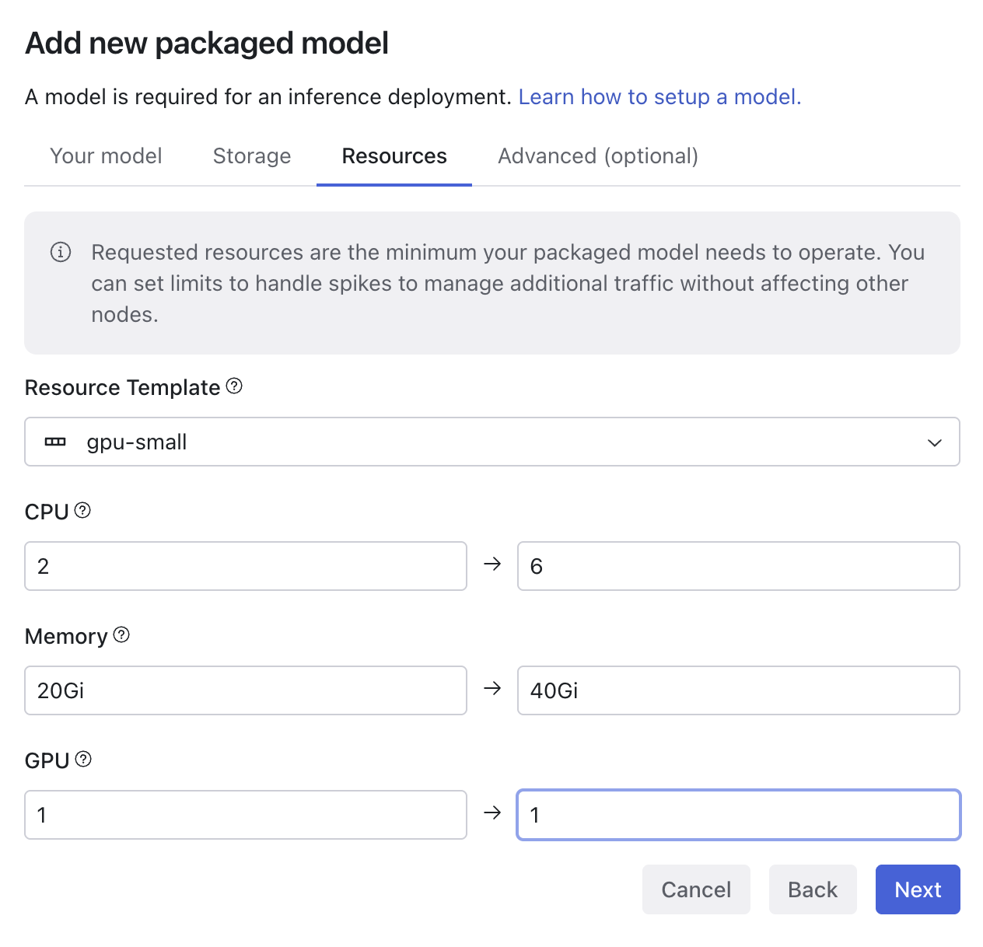

Next in the advanced settings, Add environment variable

DOMAIN_WHITELIST
[".*","http://.*","https://.*","http://.*:.*","https://.*:.*","file:///.*","*"]

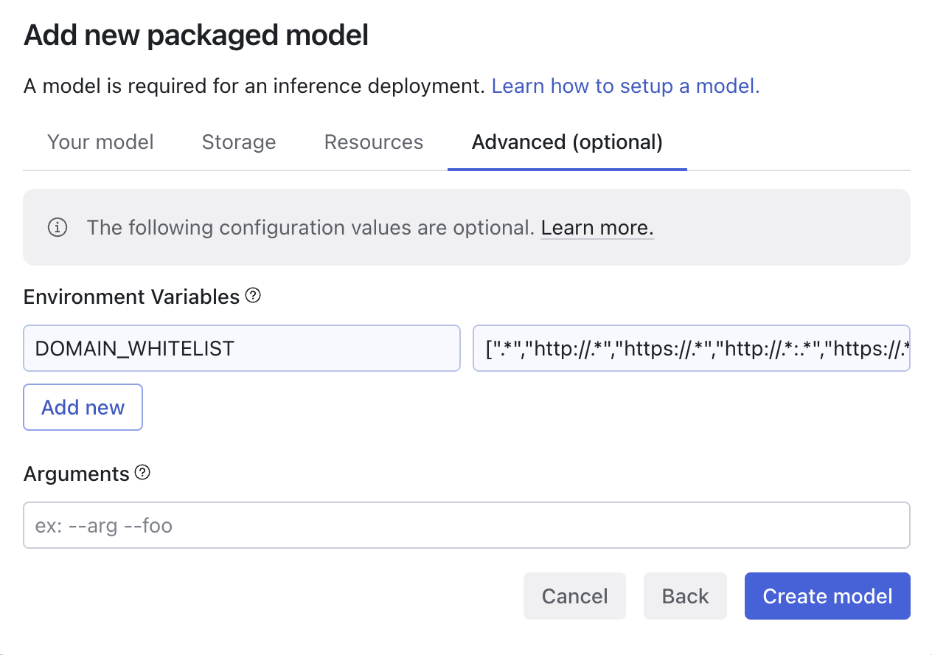

Now lets create a deployment, name your deployment same as packaged model
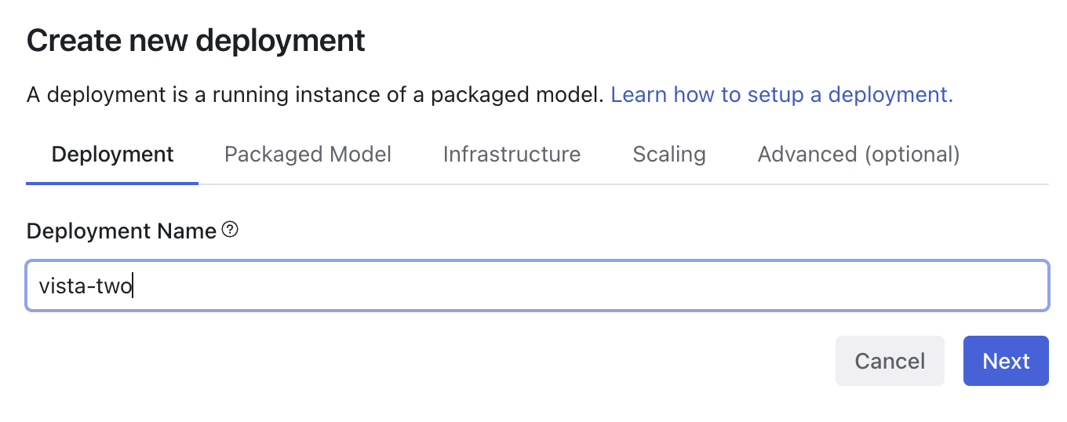
Select packaged model you just created.

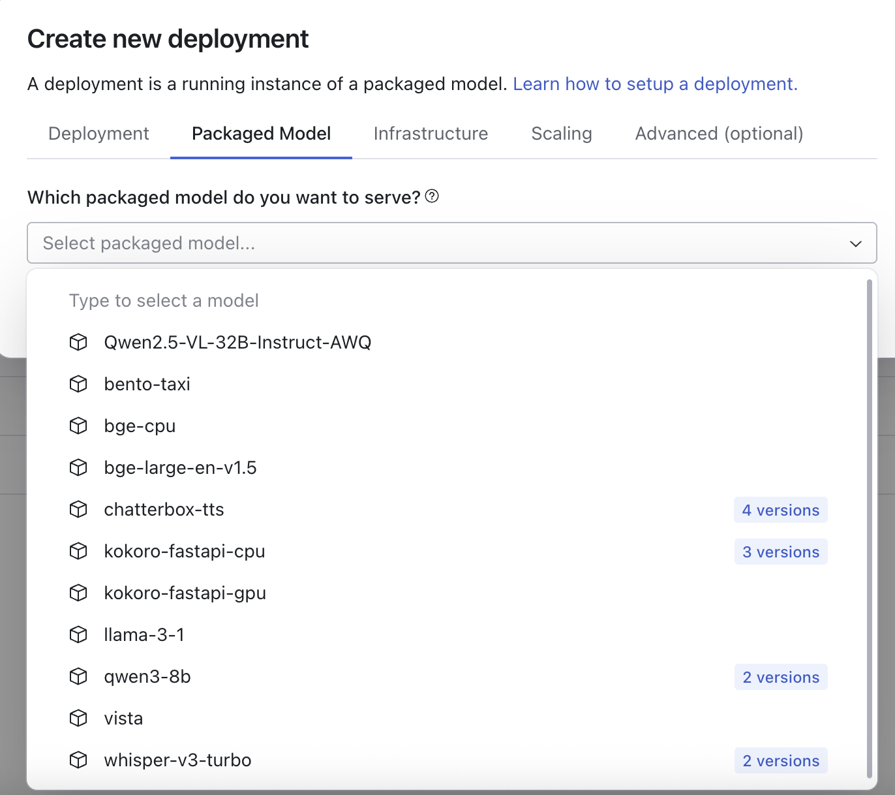next set auto scaling to fixed-1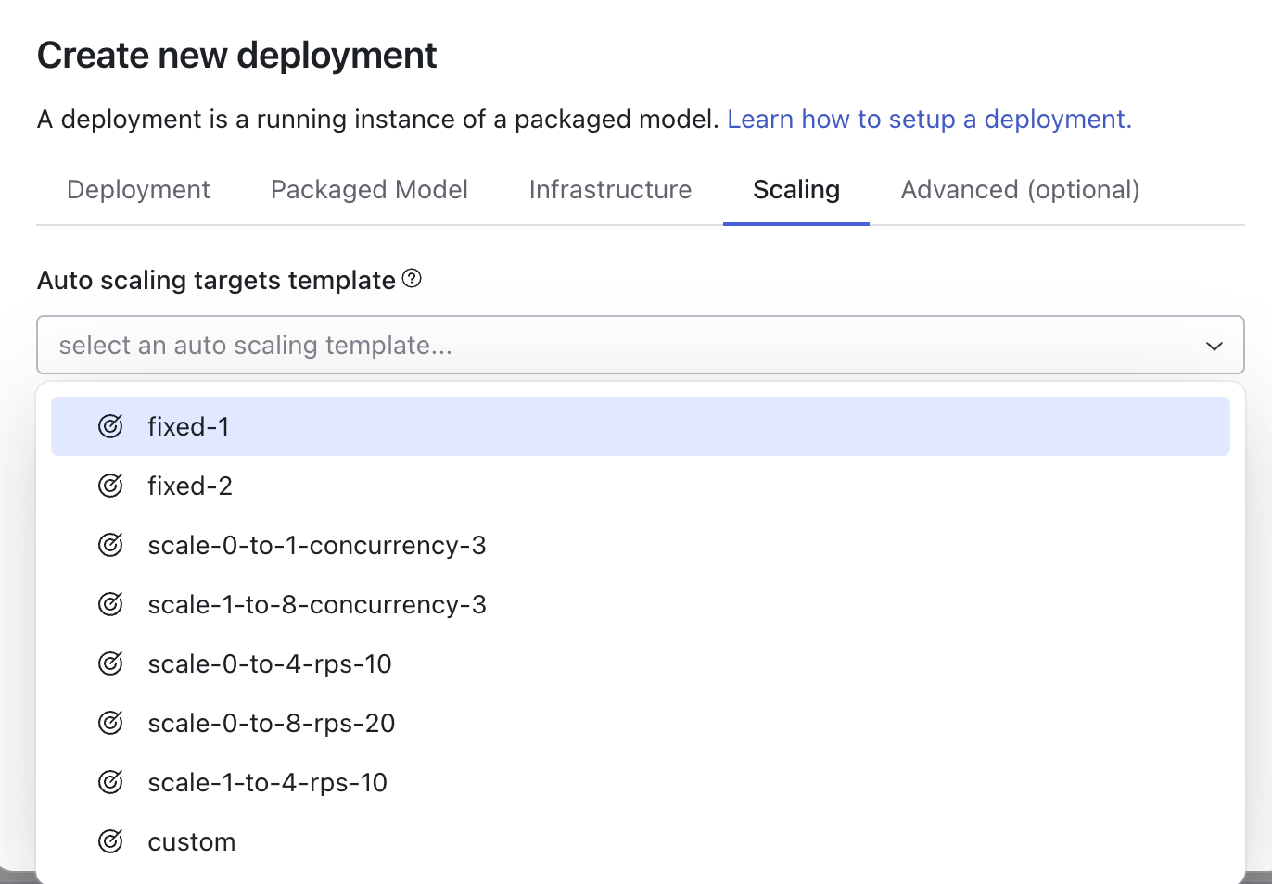

Select Done, and wait for the model to deploy, this will take a few minutes.

When its deployed, copy URL, example shown here

Next, lets make an API key
Select deployed deployment, go to users and click add new user api token
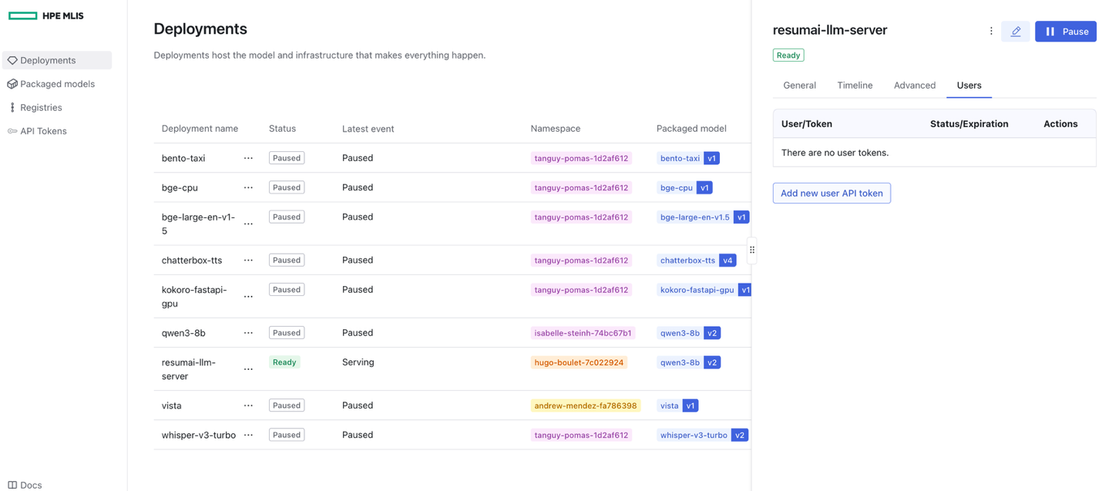
Can set the role to whatever, I usually do admin
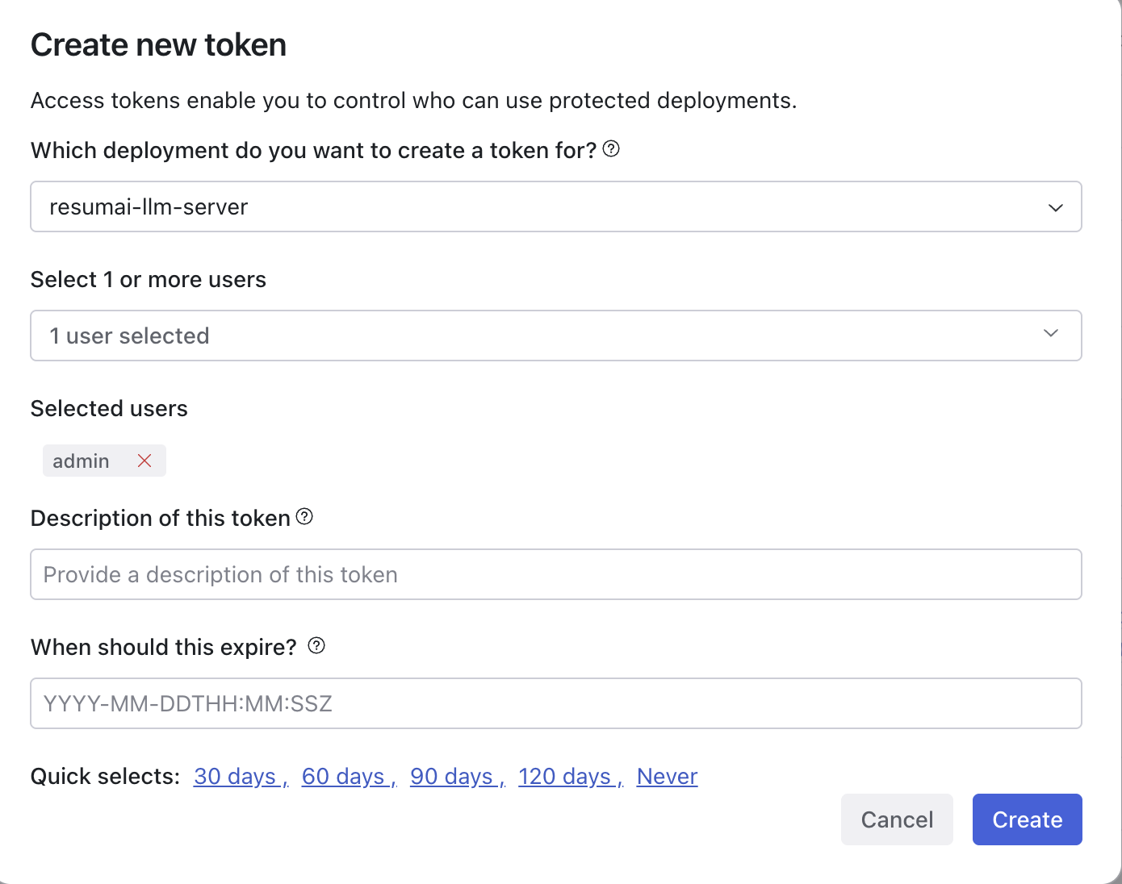

When the API is created, Select API Tokens, select all API tokens, and copy the API token shown on the right
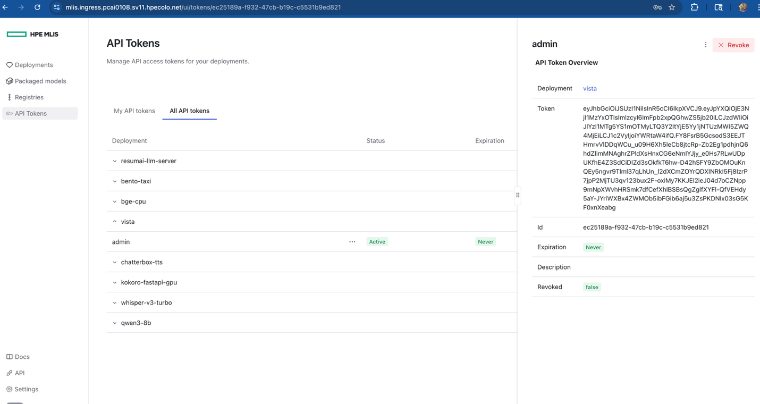
You are ready to deploy the helm chart
Pre-req; you will need the tgz file of the helm chart ready to upload.

Part 2: Install Helm chart
GO to Tools & Frameworks > Import Framework

Add name, description, and logo

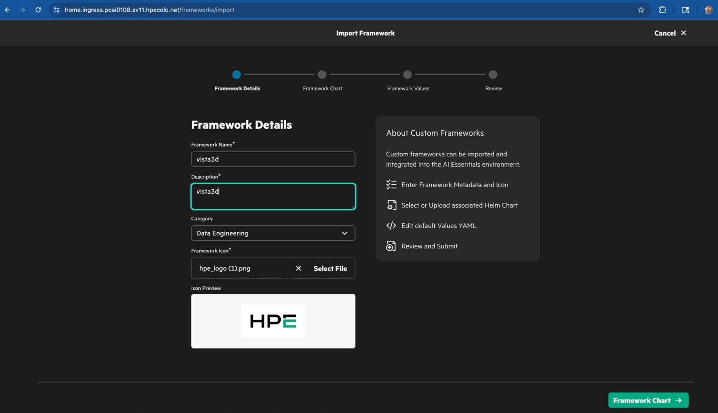
Drag .tgz of helm chart in UI, you should see this next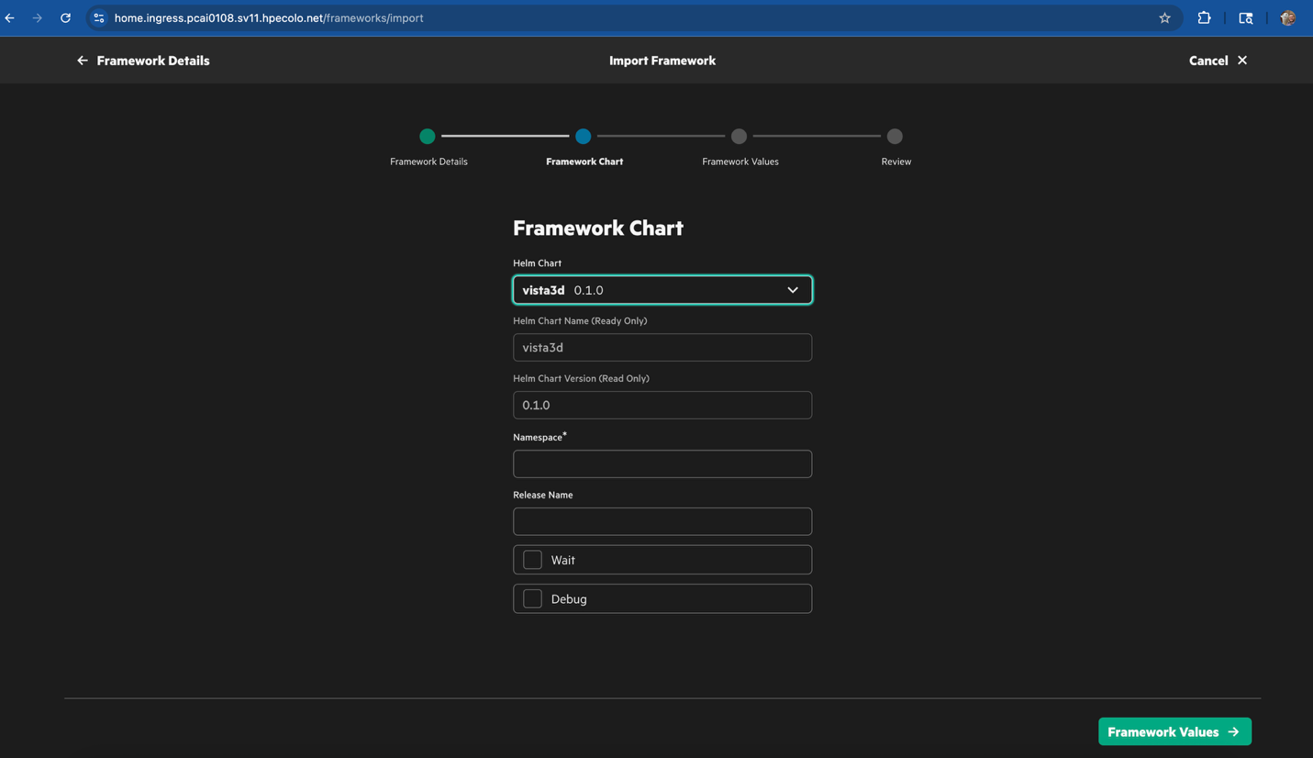
Add namespace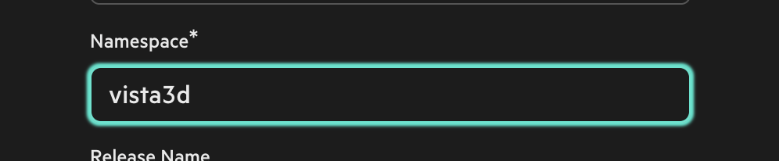
Now in the helm chart UI, only change the VISTA3D_SERVER and the VISTA3D_API_KEY

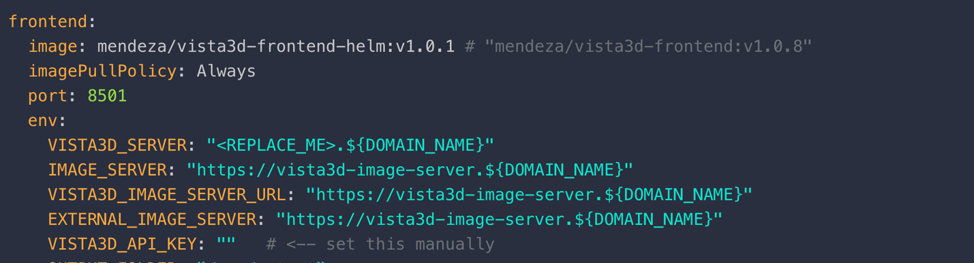

Wait until its deployed, if its deployed successfully, you should see Open Button.

